

SIMATS ENGINEERING

Saveetha Institute of Medical and Technical Sciences

Chennai-602105

September 2026

CSA0619– Design and Analysis of Algorithms

Development and Performance Analysis of a Hybrid Closest-Pair Algorithm for Geospatial Data Processing

Assignment Report

Submitted by

APSAL HAMEED.J (192524286)

ARSHATH ALI (192573012)

TARUN SATISH BABU.C(192571077)

Assignment Information

Particular | Details
Department: | ARTIFICIAL INTELLIGENCE & DATA SCIENCE
Programme: | B.E./B.Tech. AI&DS
Course Code & Course Name | Design and Analysis of Algorithms
Academic Year / Batch | 2025-2026 / Regular
Faculty Name | Dr. F. Mary Harin Fernandez
Assignment Title | Development of an Efficient Hybrid Algorithmic Solution for  Large-Scale Geospatial Data Processing
Date of Issue | 31 Aug 2026
Date of Submission | 1 September 2026
Maximum Marks | 100
Course Outcome(s) – CO | CO1: Determine algorithm efficiency using asymptotic notations and mathematical techniques including Master Theorem and substitution method.  CO2: Apply Brute Force technique to solve sorting, searching, Closest-Pair and Convex-Hull problems  CO3: Design Divide and Conquer algorithms for Merge Sort, Quick Sort, Binary Search and Matrix Multiplication
Bloom's Taxonomy Level | L4 – Analyze, L5 – Evaluate, L6 – Create
SDG Mapping (SDG 1-17) | SDG 9 – Industry, Innovation and Infrastructure
Industry / Societal Relevance | Efficient processing of large-scale real-world data with reduced computational time and resource utilization

Assignment Problem / Challenge
Modern infrastructure-planning applications process large volumes of geospatial coordinate data, making computationally efficient algorithms essential for identifying spatial relationships among facilities. Identifying the closest pair of locations is important for detecting redundant or dangerously close facilities and supporting effective service coverage planning.
Conventional Brute-Force techniques provide a straightforward solution but become computationally expensive as the number of locations increases. Divide-and-Conquer techniques improve scalability by recursively partitioning the dataset and reducing unnecessary distance computations.
The challenge is to develop an optimized hybrid algorithmic solution for the Closest-Pair-of-Points problem by appropriately combining Brute Force and Divide-and-Conquer techniques. The developed solution must determine an effective switching threshold between the two approaches and be supported by theoretical complexity analysis and experimental evaluation using a real-world geospatial dataset.

Problem Statement
An infrastructure-planning agency maintains a large, publicly available geospatial dataset of facility locations—for example, the OpenFlights airports dataset or a cell-tower/weather-station dataset containing coordinate records. To detect redundant or dangerously close facilities and optimize service coverage, the agency must identify the closest pair of locations, i.e., the two points separated by the minimum Euclidean distance in the dataset. Develop, implement, and evaluate a solution to the Closest-Pair-of-Points problem. Implement (i) a Brute-Force algorithm that evaluates all $n\left(n-1\right)/2$pairs with $O\left(n^{2}\right)$complexity and (ii) a Divide-and-Conquer algorithm that recursively partitions the point set about the median x-coordinate and evaluates points across the dividing strip with $O\left(n\log{n}\right)$complexity. Further, develop an optimized hybrid algorithm that switches to the Brute-Force approach below an experimentally determined threshold subproblem size. Analyze the theoretical efficiency of each approach using Big-O, Ω, and Θ notations, and solve the recurrence $T\left(n\right)=2T\left(n/2\right)+O\left(n\right)$using the Master Theorem. Experimentally evaluate all three algorithms on the selected dataset using increasing input sizes, for example, ${10}^{3}$, $5×{10}^{3}$, ${10}^{4}$, and higher input sizes wherever computationally feasible, measuring execution time, number of distance computations/comparisons, memory utilization, and scalability. Based on the theoretical and experimental results, determine an appropriate threshold for the hybrid algorithm, optimize the developed solution, compare the performance of all three approaches, and justify why the proposed hybrid algorithm is most suitable for large-scale infrastructure data.
Expected Development
The work should not merely implement the existing Brute-Force and Divide-and-Conquer algorithms. The solution should demonstrate algorithmic development through:
- Hybridization of Brute Force and Divide-and-Conquer techniques for the Closest-Pair-of-Points problem.
- Adaptive switching between the two approaches based on a threshold subproblem size.
- Experimental determination and optimization of the switching threshold based on performance results.
- Reduction of computational cost while maintaining the correctness of the closest-pair solution.
- Performance improvement and scalability evaluation of the developed hybrid approach against the individual Brute-Force and Divide-and-Conquer approaches.

Requirements and Constraints

The following requirements and constraints shall be considered:

- Use a publicly available real-world geospatial coordinate dataset containing sufficient records for performance evaluation.
- Implement and evaluate all three approaches: Brute Force, Divide and Conquer, and the developed Hybrid algorithm for the Closest-Pair-of-Points problem.
- Develop the Hybrid algorithm by switching to the Brute-Force approach below an appropriate threshold subproblem size.
- Determine and justify the switching threshold experimentally based on performance results.
- Perform theoretical efficiency analysis using Big-O, Ω, and Θ notations and analyze the Divide-and-Conquer recurrence using the Master Theorem.
- Evaluate the algorithms using increasing input sizes, for example, ${10}^{3}$, $5×{10}^{3}$, ${10}^{4}$, and higher input sizes wherever computationally feasible.
- Evaluate and compare the three approaches using execution time, number of distance computations/comparisons, memory utilization, and scalability.
- Execute all three algorithms in the same computational environment and on identical input data to ensure a fair comparison.
- Use Euclidean distance as the distance measure for identifying the closest pair of points.
- Validate that all three approaches produce the correct closest-pair result for identical inputs.
- Higher input sizes shall be considered only where computationally feasible, taking into account the $O\left(n^{2}\right)$computational cost of the Brute-Force approach.
- Clearly document the dataset source, experimental environment, threshold value, assumptions, limitations, and implementation details.

Student Work

Problem Understanding and Formulation

The Closest-Pair-of-Points problem asks for the two geospatial locations with the minimum Euclideanseparation "
"In infrastructure planning, the result can be used as an indicator of potentially redundant or dangerouslyclosefacilities, "
"and can support service-coverage planning. The assignment requires Brute Force, Divide and Conquer,andadevelopedHybridalgorithm, "
"with an experimentally selected switching threshold.
Dataset. The OpenFlights Airports Database was selected because it is publicly available and contains airport/facility coordinates. The source describes fields including Airport ID, Name, City, Country, IATA, ICAO, Latitude and Longitude. The working extract supplied with this submission contains 100 valid airport records from the OpenFlights snapshot.
Working dataset attributes: Airport ID, Name, Latitude, Longitude. Invalid/missing coordinate records are excluded. The experimental CSV is openflights_working_extract_100.csv.
Expected input: a collection of points represented as (latitude, longitude, name, identifier). Expected output: the two point records having minimum Euclidean distance, together with distance-computation count, execution time and peak memory measurement.
Euclidean distance is used exactly as required by the assignment: d = sqrt((x1-x2)^2 + (y1-y2)^2). The coordinates are treated as a 2-D numerical plane; the experiment therefore does not claim a geodesic/earth-surface distance.
Computational challenge. Brute Force evaluates n(n-1)/2 pairs, so its work grows quadratically. As n increases, distance evaluations and execution time rise rapidly. Divide and Conquer reduces the number of candidate comparisons by spatial partitioning. The Hybrid method further reduces recursive overhead by solving small subproblems directly with Brute Force.
Assumptions and constraints: identical input data and environment are used for all algorithms; Euclidean distance is mandatory; the algorithms must return the same closest pair; the threshold must be justified experimentally; and higher input sizes are limited by the cost of the Brute-Force baseline.

Application of Course Knowledge

CO1 – Algorithm Analysis
The work applies algorithmic problem-solving, efficiency analysis, Big-O, Ω and Θ notation, recursive/non-recursive analysis, and the Master Theorem.
CO2 – Brute Force
Every unordered pair is evaluated. For n points this produces n(n-1)/2 distance computations, giving Θ(n²) time.
CO3 – Divide and Conquer
Points are recursively divided around the median x-coordinate
The closest pair is found in each half, then a vertical strip around the division is examined using the y-order to avoid testing all cross-half pairs.
Contribution to the Hybrid algorithm
CO1 provides the complexity framework and threshold rationale; CO2 supplies the small-subproblem solver; CO3 supplies the scalable recursive structure. The Hybrid algorithm combines these by using Brute Force when n ≤ T and Divide and Conquer otherwise.

Solution / Design / Methodology

Methodology followed: Input Dataset → Data Preparation → Brute-Force Implementation → Divide-and-Conquer Implementation → Hybrid Algorithm Development → Threshold Determination → Complexity Analysis → Experimental Evaluation → Optimization → Performance Comparison → Final Decision.

3.1 Brute-Force Pseudocode
The Brute-Force method compares every possible pair of points and selects the pair with the minimum Euclidean distance.
BRUTE-FORCE(points)
best ← ∞

for i ← 0 to n − 1:
for j ← i + 1 to n − 1:
d ← EuclideanDistance(points[i], points[j])

if d < best:
best ← d
bestPair ← (points[i], points[j])

return bestPair, best

3.2 Divide-and-Conquer Pseudocode
The Divide-and-Conquer method divides the points into two halves, solves each half recursively, and then checks whether a closer pair exists across the dividing line.
DIVIDE-AND-CONQUER(points)

if n ≤ 3:
return BRUTE-FORCE(points)

divide points at the median x-coordinate

leftResult ← DIVIDE-AND-CONQUER(left half)
rightResult ← DIVIDE-AND-CONQUER(right half)

δ ← minimum distance from leftResult and rightResult

strip ← points within distance δ
from the dividing line

sort/check strip in y-coordinate order

compare only nearby points in the strip

return the smallest distance and corresponding pair
return the smallest result

3.3 Developed Hybrid Pseudocode
The proposed Hybrid algorithm combines the Brute-Force and Divide-and-Conquer approaches. Small datasets are solved using Brute Force, while larger datasets use the Divide-and-Conquer method.
HYBRID(points, threshold T)

sort points by x-coordinate
sort points by y-coordinate

return HYBRID-REC(px, py, T)

HYBRID-REC(px, py, T)

if number of points ≤ T:
return BRUTE-FORCE(px)

divide points at the median x-coordinate

leftResult ← HYBRID-REC(left half, T)
rightResult ← HYBRID-REC(right half, T)

δ ← minimum of leftResult and rightResult

build a strip containing points
within distance δ of the dividing line

compare nearby points in the strip

return the minimum result

3.4 Flowchart / Design
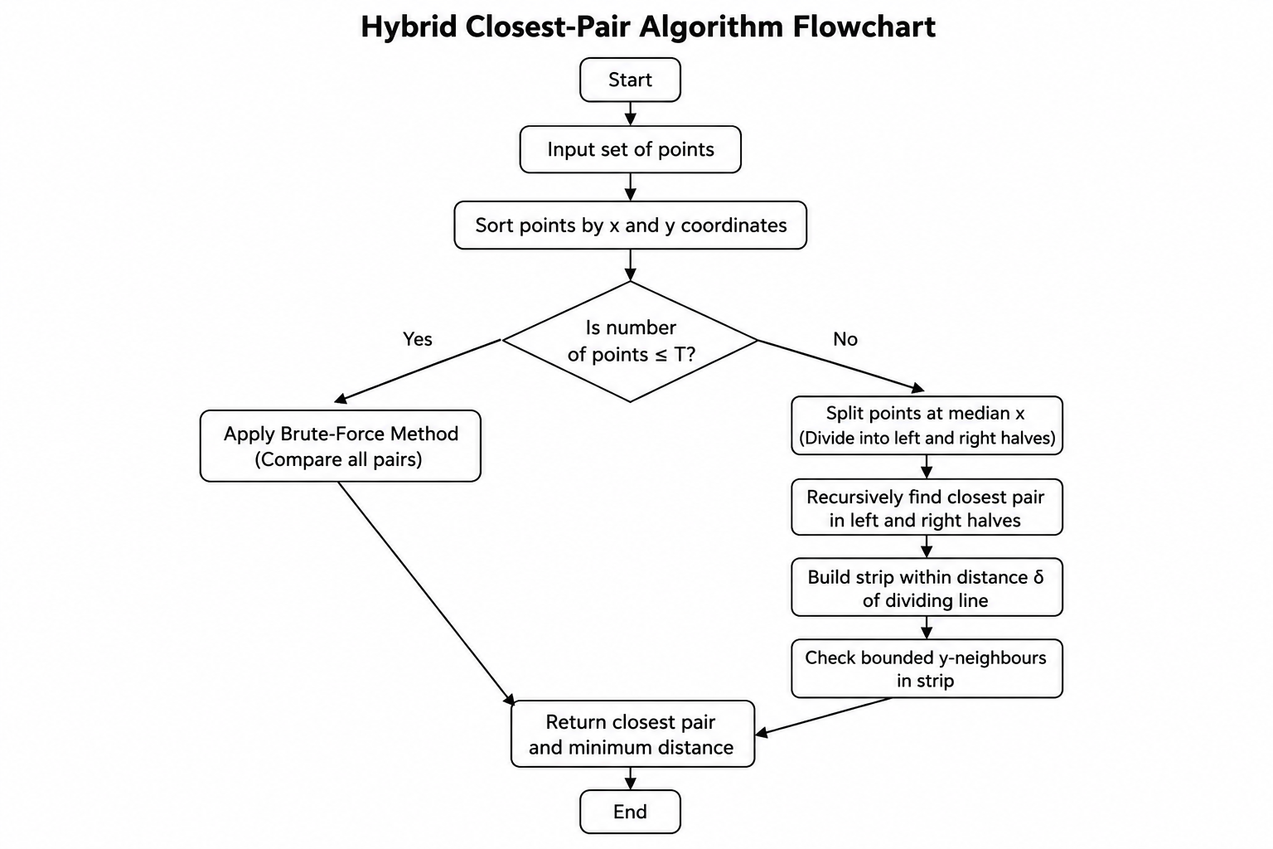
Figure 1. Flow of the proposed Hybrid Closest-Pair algorithm.

3.5 Hybrid Switching Strategy
The Hybrid algorithm uses a threshold value T to decide which method should be applied.
- When n ≤ T, the algorithm uses the Brute-Force method.
- When n > T, the algorithm uses the Divide-and-Conquer method.
This strategy improves efficiency by avoiding unnecessary recursive operations for small datasets while using the faster Divide-and-Conquer approach for larger datasets.

3.6 Method Used to Determine the Threshold
Different threshold values were tested to identify the best value for the Hybrid algorithm. The tested threshold values were:
T ∈ {4, 8, 12, 16, 20, 24, 32}
The algorithm was tested using input sizes of 10, 20, 40, 60, 80, and 100 points. Each test was performed five times, and the median execution time was recorded.
Threshold | Mean Hybrid Time (s) | Relative to Best
16 | 0.000237 | 1.000×
12 | 0.000246 | 1.038×
20 | 0.000260 | 1.099×
24 | 0.000266 | 1.124×
8 | 0.000279 | 1.178×
32 | 0.000323 | 1.366×
4 | 0.000421 | 1.777×
Based on the experimental results, T = 16 was selected because it produced the lowest average execution time of approximately 0.000237 seconds. However, this threshold is specific to the current implementation and testing environment.

3.7 Mathematical Complexity Analysis

Brute-Force Algorithm
The Brute-Force method compares every possible pair of points.
T(n)=n(n−1)2T(n) = \frac{n(n-1)}{2}
Therefore, its time complexity is:
- Best Case: Ω(n²)
- Worst Case: O(n²)
- Overall Complexity: Θ(n²)
The additional space complexity is O(1).

Divide-and-Conquer Algorithm
The Divide-and-Conquer algorithm divides the problem into two smaller subproblems and processes the dividing strip.
T(n)=2T(n/2)+O(n)T(n) = 2T(n/2) + O(n)
Using the Master Theorem, the overall complexity is:
Θ(nlog⁡n)\Theta(n \log n)
Therefore:
- Best Case: Ω(n log n)
- Worst Case: O(n log n)
- Overall Complexity: Θ(n log n)
The auxiliary space required is O(n).

Hybrid Algorithm
For small inputs where n ≤ T, the algorithm uses Brute Force:
Θ(n2)\Theta(n²)
For larger inputs where n > T, it follows:
T(n)=2T(n/2)+O(n)T(n) = 2T(n/2) + O(n)
Since the threshold T is fixed, the overall asymptotic complexity remains:
Θ(nlog⁡n)\Theta(n \log n)
The Hybrid algorithm can provide better practical performance because it reduces recursive overhead for smaller subproblems.

3.8 Design and Optimization Decisions
Several optimization techniques were used in the developed Hybrid algorithm:
- Pre-sorting: Points are sorted by both x and y coordinates only once at the beginning.
- Reduced Sorting: The algorithm avoids repeatedly sorting points during recursive calls.
- Efficient Strip Processing: Points near the dividing line are processed in y-coordinate order.
- Limited Comparisons: Only nearby points in the dividing strip need to be compared.
- Hybrid Base Case: Small subproblems are solved directly using the Brute-Force method.
- Performance Measurement: A distance-computation counter is used to measure computational work separately from execution time.
These optimization decisions help improve the practical efficiency of the proposed Hybrid Closest-Pair algorithm.

Use of Modern Tools
Python 3 was used to implement the proposed Hybrid Closest-Pair algorithm. The program can be executed using a command prompt or any Python IDE. The csv module was used for reading and processing the dataset, while pandas was used for analysing the experimental results.
The time.perf_counter() function was used to measure execution time, and tracemalloc was used to measure peak memory usage during execution. Performance graphs were generated using matplotlib.
The source code was stored in hybrid_closest_pair.py, and the working dataset was stored in openflights_working_extract_100.csv.

Execution Command
python hybrid_closest_pair.py --csv openflights_working_extract_100.csv --out results.csv --threshold 16

Experimental Environment
All three algorithms—Brute Force, Divide-and-Conquer, and Hybrid—were executed in the same Python environment using identical input data. This ensured a fair comparison of execution time, memory usage, and overall algorithm performance.

Results and Validation
All three implementations—Brute Force, Divide-and-Conquer, and the proposed Hybrid algorithm—returned the same closest pair for every tested input size. This confirms the correctness and consistency of the algorithms.
For the 100-record OpenFlights working extract, the closest pair identified was Ottawa/Gatineau Airport and Ottawa Macdonald-Cartier International Airport, with a Euclidean distance of 0.22546189 coordinate units.
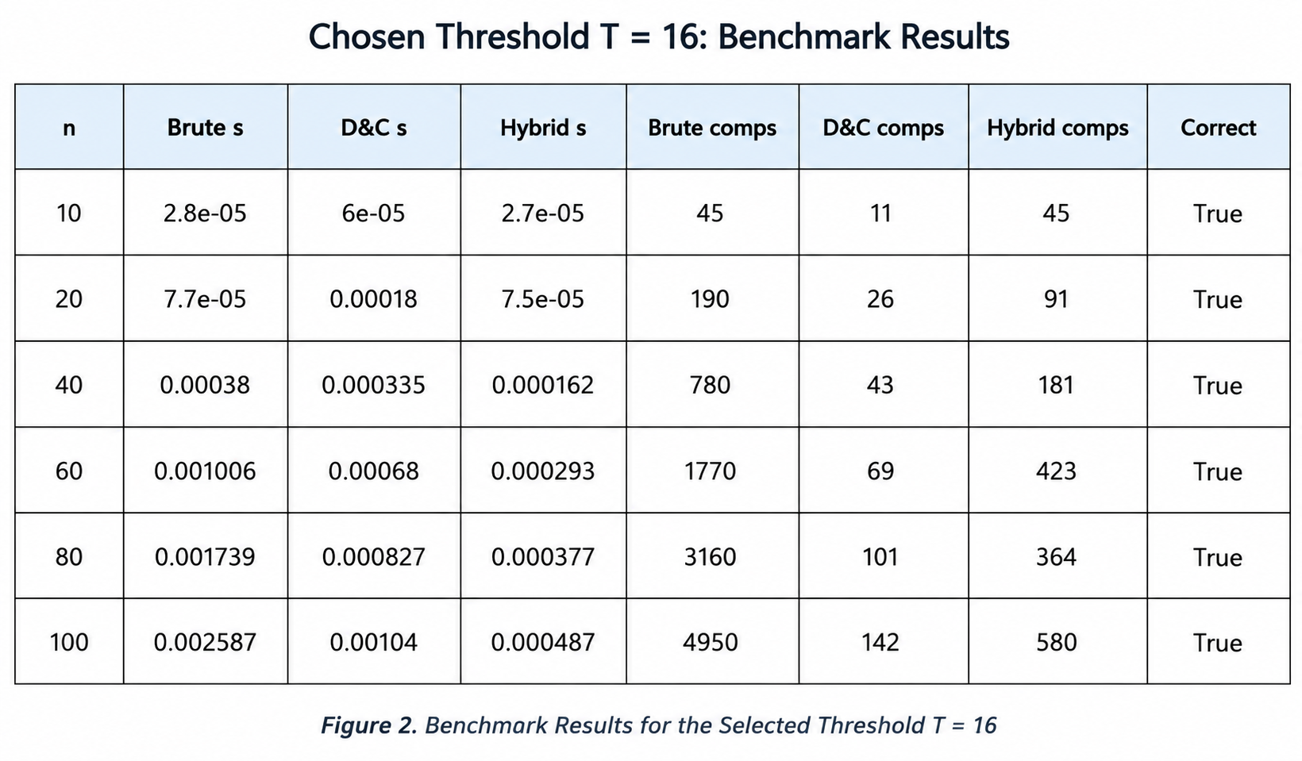
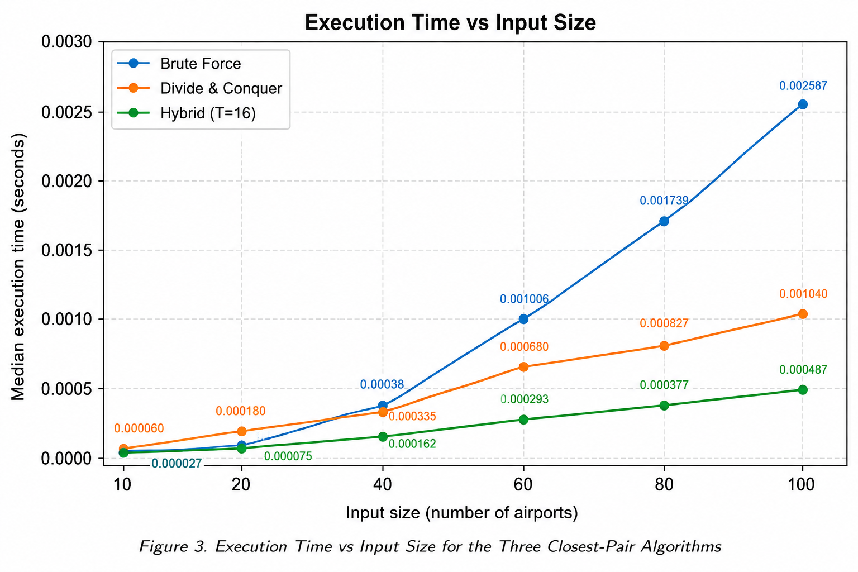
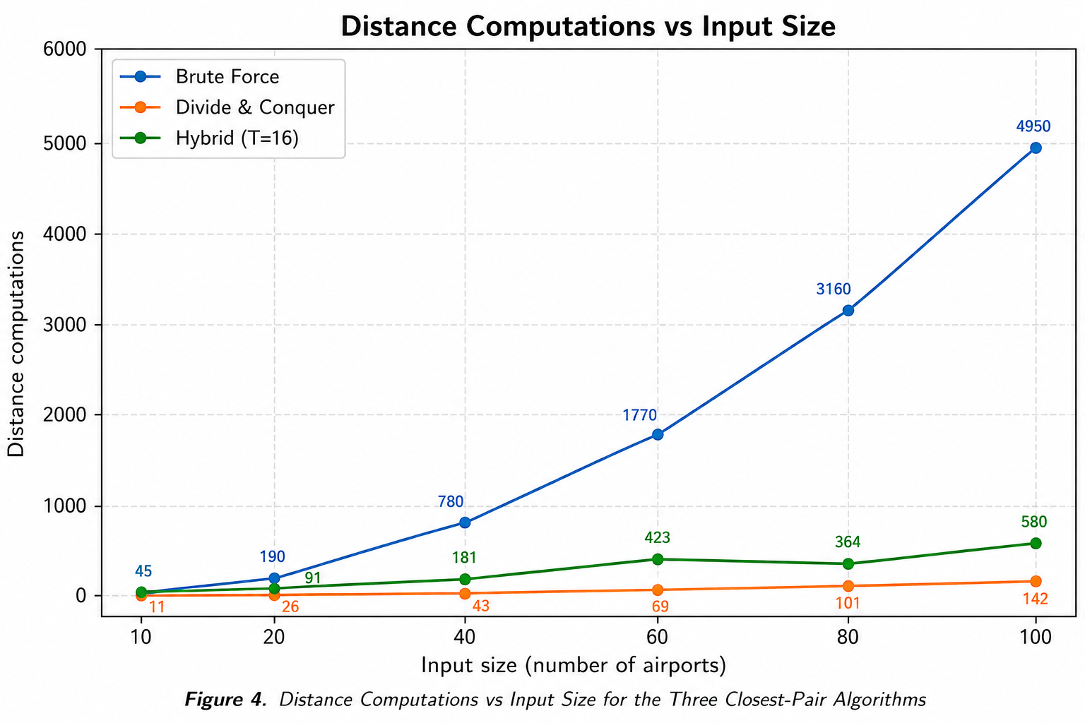
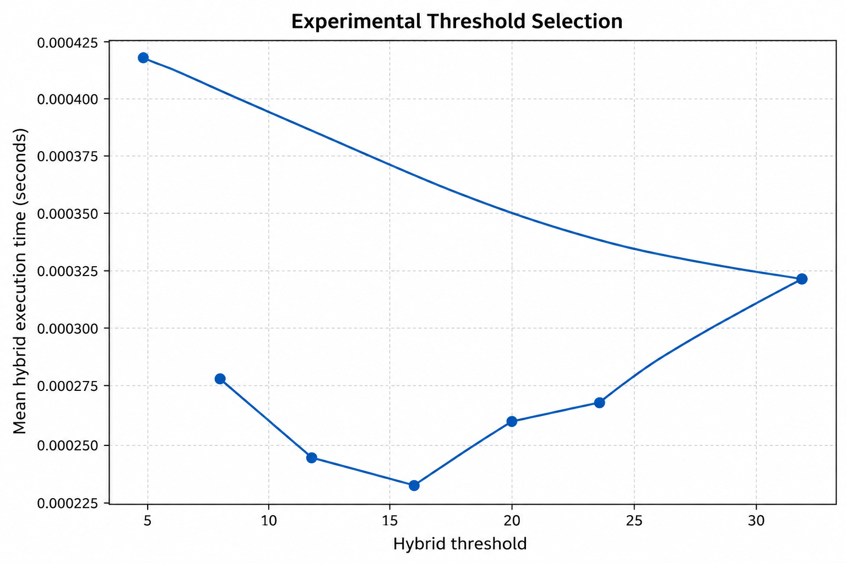
Figure 5. Experimental threshold selection.

The performance of the three algorithms was evaluated using six different input sizes ranging from 10 to 100 records.
Input Size (n) | Brute Force (s) | D&C (s) | Hybrid (s) | Brute Comparisons | Hybrid Comparisons
10 | 0.000028 | 0.000060 | 0.000027 | 45 | 45
20 | 0.000077 | 0.000180 | 0.000075 | 190 | 91
40 | 0.000380 | 0.000335 | 0.000162 | 780 | 181
60 | 0.001006 | 0.000680 | 0.000293 | 1770 | 423
80 | 0.001739 | 0.000827 | 0.000377 | 3160 | 364
100 | 0.002587 | 0.001040 | 0.000487 | 4950 | 580
Across all six tested input sizes, the mean execution times were:
- Brute Force: 0.000970 seconds
- Divide and Conquer: 0.000520 seconds
- Hybrid: 0.000237 seconds
The Hybrid algorithm was approximately 4.10× faster than Brute Force and 2.20× faster than Divide and Conquer in this small-scale benchmark.
The validation results also confirmed that correct = True for every tested input size when T = 16. This means that the Hybrid and Divide-and-Conquer algorithms produced the same closest-pair distance as the Brute-Force algorithm within the implemented numerical tolerance.

Analysis and Engineering Decision
Brute Force has the simplest logic and the lowest algorithmic overhead, so it is appropriate for very small point sets. However, its Θ(n²) pair growth makes it unsuitable for large datasets. The 100-point run required 4,950 distance computations.
Divide and Conquer reduces the candidate comparisons substantially. At n=100 it required 142 distance computations in this implementation, versus 4,950 for Brute Force. Its additional ordering and recursion overhead is visible in the memory measurement.
The Hybrid algorithm combines the advantages of both. At n=100 and T=16 it required 580 distance computations and had lower measured runtime than either baseline. The Hybrid threshold experiment showed that very small thresholds retain more recursive overhead, while very large thresholds perform too much quadratic work inside the leaves. T=16 gave the best measured balance.
The theoretical and experimental results agree in direction: quadratic growth makes Brute Force increasingly expensive, while Divide and Conquer and Hybrid scale more favourably. Because the working dataset contains only 100 records, implementation benchmark rather than a claim of production-scale performance.
Engineering decision: the developed Hybrid approach is the most suitable of the three for large-scale geospatial infrastructure data because it retains Θ(n log n) asymptotic behaviour while using the lower-overhead Brute-Force solver on small subproblems. The decision is supported by the measured mean runtime and by the reduction in distance computations relative to Brute Force.
Advantages and limitations. Brute Force: simplest, easy to validate, but poor scalability. Divide and Conquer: strong asymptotic performance, but more implementation complexity and auxiliary memory. Hybrid: combines scalability with lower small-instance overhead, but its threshold is implementation- and hardware-dependent and must be re-tuned when conditions change.

Broader Considerations

Efficient resource utilization is achieved by avoiding unnecessary pairwise distance evaluations. The spatial divide-and-conquer structure reduces the candidate set, while the Hybrid base case avoids recursion where it is not beneficial. This can improve throughput when many infrastructure datasets or repeated planning queries are processed.
The approach can support infrastructure planning by identifying locations that are unusually close under the selected Euclidean model. A production system could extend the same design to facility screening, service-area analysis, duplicate-location detection, or pre-processing before more detailed spatial analysis.
Sustainable computational development is supported through reduced computation and better scalability, which can lower processing time and resource demand for repeated analyses.
SDG 9 – Industry, Innovation and Infrastructure. The solution demonstrates an algorithmic method for making infrastructure-data processing more efficient and scalable. Efficient spatial analytics can contribute to intelligent planning systems by enabling larger datasets to be analyzed with fewer unnecessary computations.

Conclusion
The Closest-Pair-of-Points problem was addressed using a real-world OpenFlights airport-coordinate dataset. Brute Force, Divide and Conquer, and a newly developed Hybrid algorithm were implemented and evaluated under identical conditions.
The Hybrid algorithm switches to Brute Force for subproblems of size T=16 and otherwise uses Divide and Conquer. The threshold was selected experimentally from candidate values 4, 8, 12, 16, 20, 24 and 32.
For the tested sizes 10–100, all approaches produced the same closest pair. The Hybrid approach had the lowest mean measured execution time in the experiment, approximately 0.000237 s, compared with 0.000970 s for Brute Force and 0.000520 s for Divide and Conquer. The main scalability improvement is the change from Θ(n²) pair growth in Brute Force to Θ(n log n) asymptotic behaviour for the Divide-and-Conquer and Hybrid methods.
Limitations include the 100-record working extract, the use of Euclidean rather than geodesic distance, and the dependence of the threshold on implementation and hardware. Future optimization can use the complete OpenFlights dataset, parallel or vectorized distance operations, spatial indexing, geodesic distance when required, and automated threshold tuning.

Student Reflection
Answer individually:
What did you learn from developing and optimizing the Hybrid Closest-Pair algorithm beyond implementing the algorithms directly taught in the classroom?

The main learning was that algorithm performance is not determined only by Big-O notation. The practical cost of recursion, sorting, memory allocation and function calls matters for small subproblems. I learned how to combine two known strategies into a hybrid design and how to use measured evidence to select a switching point rather than choosing a threshold arbitrarily.

What challenges did you encounter while determining the switching threshold and evaluating performance across different input sizes, and how did you address them?

The main challenge was that execution times for small inputs are very short and can be affected by runtime noise. I addressed this by repeating each measurement several times and using the median time. I also compared distance-computation counts, because they provide a more stable algorithmic-work measure than timing alone. Correctness was checked by comparing every Hybrid and Divide-and-Conquer result against Brute Force.
If additional computational resources or time were available, how would you further improve the developed algorithm and why?

I would evaluate the complete OpenFlights dataset and much larger subsets, automate threshold tuning over several hardware configurations, and compare Euclidean with geodesic distance. I would also investigate spatial indexing or parallel processing for repeated queries. These changes would improve scalability and make the engineering conclusions more representative of production workloads.

How can the developed solution contribute to SDG 9 – Industry, Innovation and Infrastructure?

The solution demonstrates how algorithmic optimization can make infrastructure-data processing faster and more scalable. Reducing unnecessary distance computations can support intelligent infrastructure planning systems that analyze more facilities within the same computational budget.

References

OpenFlights. Airport, airline and route data – Airport Database. https://openflights.org/data (accessed September 2, 2026).

Cormen, T. H., Leiserson, C. E., Rivest, R. L., & Stein, C. Introduction to Algorithms, 4th ed., MIT Press, 2022.

Python Software Foundation. Python 3 Documentation – time, csv, math and tracemalloc modules. https://docs.python.org/3/

Matplotlib Development Team. Matplotlib Documentation. https://matplotlib.org/stable/

OpenAI ChatGPT. AI-assisted support was used for organizing the report, drafting implementation structure, and reviewing the experimental methodology; the code was executed and the reported measurements were generated in the supplied execution environment.

Assessment Rubric

Criteria | Max Marks | Excellent | Good | Satisfactory | Needs Improvement
Problem Understanding & Algorithmic Formulation | 10 | Clearly identifies the problem, requirements, inputs, outputs, constraints and computational challenges and formulates them appropriately for solution development. | Problem and major requirements are correctly formulated with minor gaps. | Basic formulation is provided, but requirements or constraints are partially identified. | Problem is poorly understood or inadequately formulated.
Algorithmic Solution Design | 15 | Designs a clear, logical and feasible solution strategy with appropriate algorithmic techniques, pseudocode/flowchart and well-justified design decisions. | Appropriate solution design with minor gaps in logic, representation or justification. | Basic solution design is presented but lacks completeness or clear justification. | Solution design is inappropriate, incomplete or unclear.
Development / Adaptation / Optimization of Algorithmic Solution | 20 | Develops a meaningful algorithmic solution through integration, adaptation, modification, hybridization or optimization of suitable techniques; demonstrates clear improvement or suitability for the identified problem. | Develops an appropriate solution with meaningful adaptation or improvement, with minor limitations. | Solution demonstrates limited adaptation or development beyond standard implementation. | Merely reproduces an existing algorithm with little or no meaningful development or adaptation.
Implementation & Modern Tool Usage | 15 | Developed solution is correctly and efficiently implemented using appropriate programming/computational tools and handles relevant input conditions reliably. | Implementation is functional with minor logical or efficiency issues. | Core implementation works but contains limitations or incomplete functionality. | Implementation is incomplete, unreliable or non-functional.
Efficiency, Testing & Validation | 15 | Performs appropriate complexity evaluation and systematic testing using suitable data/input sizes; validates correctness, efficiency and scalability with clear evidence. | Complexity evaluation and testing are mostly appropriate with minor gaps. | Basic testing and efficiency evaluation are provided but lack sufficient validation. | Testing, complexity evaluation or validation is inadequate or substantially incorrect.
Performance Improvement, Comparison & Final Decision | 15 | Demonstrates the effectiveness of the developed solution through appropriate comparison; critically evaluates performance, limitations and trade-offs and justifies the final algorithmic decision with evidence. | Good performance comparison and justification with minor limitations. | Basic comparison is provided, but improvement or final justification lacks depth. | Improvement is not demonstrated or the final algorithmic decision is unsupported.
Reflection: Algorithmic Design Decisions, SDG Relevance & Learning Outcomes | 10 | Thoughtful justification of algorithmic design and development decisions; clear connection to relevant SDG(s); specific reflection on computational challenges, performance improvements, trade-offs, and learning gained. | Appropriate justification of algorithmic decisions; SDG relevance, challenges, improvements, and learning are discussed but lack depth. | Reflection is present but generic; limited justification of algorithmic decisions, improvements, SDG relevance, or learning outcomes. | No genuine reflection is provided, or the reflection lacks meaningful connection to algorithm development, SDG relevance, challenges, or learning outcomes.
Total | 100

CO–PO–Assessment Mapping

Assessment Component | CO | PO(s) | Bloom's Level | Marks
Problem Understanding & Algorithmic Formulation | CO1 | PO1, PO2 | L4 | 10
Algorithmic Solution Design | CO2, CO3 | PO2, PO3 | L4, L6 | 15
Development / Adaptation / Optimization of Algorithmic Solution | CO2, CO3 | PO2, PO3 | L5, L6 | 20
Implementation & Modern Tool Usage | CO2, CO3 | PO3, PO5 | L3, L6 | 15
Efficiency, Testing & Validation | CO1, CO2, CO3 | PO2, PO4 | L4, L5 | 15
Performance Improvement, Comparison & Final Decision | CO1, CO2, CO3 | PO2, PO4 | L4, L5 | 15
Reflection: Algorithmic Design Decisions, SDG Relevance & Learning Outcomes | CO1, CO2, CO3 | PO7, PO10, PO12 | L4, L5 | 10

Faculty Evaluation & Continuous Improvement CO Attainment

Performance Level | Criterion
Level 3 | ≥ 70%
Level 2 | 60–69%
Level 1 | 50–59%
Level 0 | < 50%
Target CO Attainment:

Actual CO Attainment:

Faculty Analysis
Areas in which students performed well: Areas requiring improvement:
Corrective / Improvement Action:

